
Frimley & Camberley Cadet Corps
Caird Hall
Crawley Hill
Camberley
Surrey

Dear Parents / Guardians

SHOOTING @ FRIMLEY CADET TRAINING CENTRE – 10/02/09

Training Company and Senior Company will be shooting together. Should you need directions please see map below, or ask your Instructor.

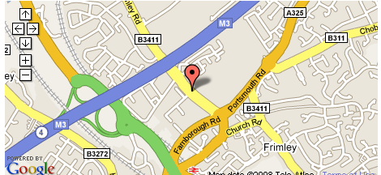

Please bring this letter with you when dropping and picking up you child, and please make sure that you are on time.

The times for the evening are 6:45pm drop off for a 7:00pm start. Pickup is 9:00pm. Please once again make sure that you are prompt on this evening.

Yours faithfully

C/Sgt S Josling
Training Company

